Error: Reference source not found
–
Document ID: 0000.doc
Author(s): TN Team
Version: 0.2
Date: March 20 , 2024

1. Objective and Scope 3
2. Project End Users 3
3. Features 4
3.1 Login to the system 4
3.2 Add the product 4
3.3 select the product 4
3.4 Request duration for the product 4
3.5 Product delivery Details 6
3.6 Transaction Details 7
3.7 Delivery Product....................................................................................................8

Objective and Scope
The objective and the scope of the project is to build a Rent Services System that is capable of handling the rent product to the people who wants to rent the product for certain duration, show the user’s product to others etc.
The scope of the Rent Service System includes the following basic features:
- The system will receive product details such as name, category (furniture, electronics, fashion, vehicles, houses, villas, apartments, tools, devices), description, and version details from the owner. A unique ID will be assigned to each product, and confirmation will be sent back to the owner.
- Owners can create rental campaigns by providing the product ID (assigned at the first point), variable fields such as rental price, availability schedule, and other details like user restrictions or special offers. Upon submission, a unique campaign ID is generated and returned to the owner.
- The system validates the campaign details and schedules rentals accordingly. If validation errors occur, the system proceeds with the campaign only if less than 5% of the records are invalid. Otherwise, the information is sent back to the owner for modifications and re-submission.On the schedule date and time mails will be delivered.
- Users can inquire about the status of their rental campaigns by providing the campaign ID. Information such as rental availability, duration, and any ongoing rentals will be provided.
- The system generates reports on various aspects such as rental activity, revenue generated, popular products, and user feedback.

Project End Users
Those who require to rent the product or to be rent their product can be integrate this system along with others.
- End users may vary in their familiarity and proficiency with the system. Some may be experienced and tech-savvy, while others may be new to the platform and require more guidance.
- Understanding the diverse needs and expectations of end users is crucial. They may have different goals and objectives when using the system, so it's essential to cater to their specific requirements.
- End users may have preferences regarding the user interface design, layout, and navigation. Ensuring an intuitive and user-friendly interface can enhance their overall experience and productivity.
- Considering accessibility requirements ensures that the system is usable by all end users, including those with disabilities. This may involve features such as screen reader compatibility, keyboard navigation, and color contrast options.
FLOW CHART
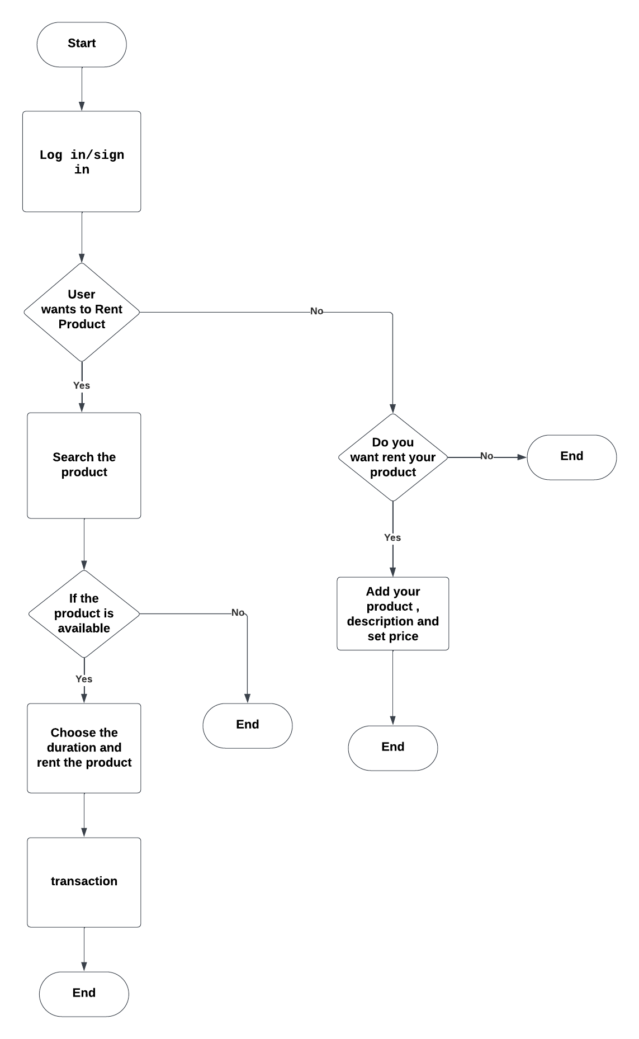

CLASS DIAGRAM

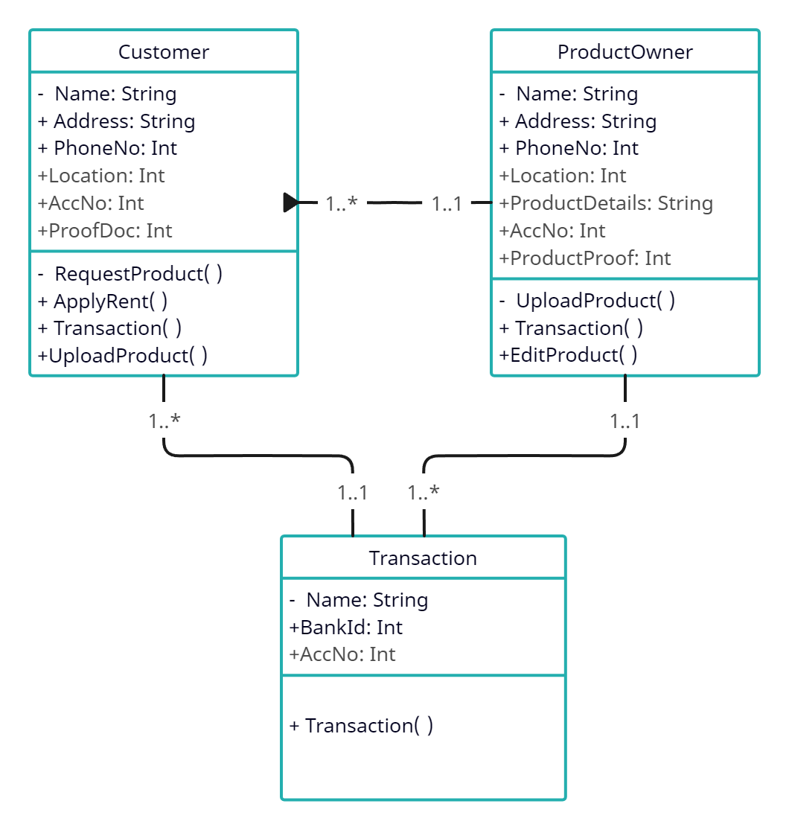
ER DIAGRAM

Features

Login to the system
Each and every user should be authenticated with a User Name and Password to login into the system.
Validations for User Name and Password.
User Name: It accepts only Alphabets, Numbers, Dot (.) symbol and Underscore (_) symbol.
Password: It can be anything of the users’ choice.
(Next release we have plan to integrate IDM for windows authentication)

Add / EDIT THE PRODUCT
Add PRODUCT:
Adding a product is a fundamental function within the system, allowing users to expand their offerings and attract potential customers. This process typically involves inputting essential details such as the product name, description, category, pricing, and availability. Additionally, users may upload images or provide specifications to showcase the product effectively. Depending on the system's design, users might also have the option to define variable fields or attributes specific to their product type. Once all necessary information is provided, the system assigns a unique identifier to the product, ensuring efficient tracking and management. Clear and intuitive interfaces streamline the product addition process, empowering users to quickly and accurately list their items. Overall, the "add product" feature plays a pivotal role in maintaining a dynamic and comprehensive catalog, driving engagement and facilitating transactions within the platform.
Edit PRODUCT:
The "edit product" feature empowers users to refine and update their product listings as needed, ensuring accuracy and relevance within the system. This functionality typically allows users to modify various aspects of a product, including its name, description, category, pricing, and availability. Users may also have the option to update images, specifications, or additional details to better showcase the product. With intuitive interfaces and straightforward editing tools, users can swiftly make adjustments to their listings, reflecting changes in inventory, pricing strategies, or product specifications. By facilitating seamless updates, the "edit product" feature enables users to maintain a dynamic and up-to-date catalog, enhancing the overall user experience and maximizing the potential for successful transactions within the platform.

Select the product
The "select product" function is pivotal within the system, offering users the ability to browse and choose from a diverse array of offerings tailored to their needs. This feature typically presents users with an intuitive interface, enabling them to navigate through categories, filter options, and search functionalities to find the desired product efficiently. Upon identifying a suitable item, users can select it to proceed with further actions such as rental, purchase, or viewing detailed information. Clear presentation of product details, including images, descriptions, and pricing, enhances the selection process, providing users with the necessary information to make informed decisions. The "select product" feature thus serves as a gateway to accessing the platform's offerings, facilitating seamless interaction and engagement with the available products.

Request duration for the product
The "Request duration for the product" feature allows users to specify the duration for which they intend to rent or utilize a product within the system. This functionality plays a crucial role in facilitating seamless transactions and managing inventory effectively. Users typically input the desired start and end dates for their rental period, enabling the system to calculate the total duration and pricing accordingly. Clear communication of rental durations ensures transparency and helps users plan their usage effectively. Additionally, providing flexibility in selecting durations accommodates varying needs and preferences among users. By offering this feature, the system enhances user satisfaction and streamlines the process of renting products, ultimately contributing to a positive user experience.

Product delivary details
Product delivery details are essential components of any transaction within the system, providing users with crucial information regarding the logistics and timeline of receiving their chosen products. This feature typically includes details such as shipping address, delivery method, estimated delivery date, and any associated costs. Clear communication of these details ensures transparency and allows users to plan accordingly. Additionally, providing tracking information enables users to monitor the status of their delivery in real-time, enhancing their overall experience and instilling confidence in the system. By facilitating smooth and reliable product deliveries, this feature contributes to customer satisfaction and fosters trust in the platform's services.

View Transaction Details
The "view transaction details" feature offers users comprehensive insights into their past transactions within the system, serving as a valuable tool for monitoring and managing their activities. This functionality typically presents users with a detailed summary of each transaction, including information such as transaction date, product details, payment method, and status. Users can review past transactions to track their rental or purchase history, reconcile payments, and obtain receipts or invoices as necessary. Clear presentation of transaction details enables users to quickly retrieve relevant information and address any inquiries or discrepancies effectively. Additionally, providing access to transaction histories fosters transparency and accountability, enhancing trust and satisfaction among users. Overall, the "view transaction details" feature plays a crucial role in empowering users to stay informed and in control of their interactions within the platform.

Reports
The delivery of products is a pivotal aspect of the user experience within the system, ensuring that users receive their chosen items in a timely and satisfactory manner. This feature encompasses the entire process of preparing, dispatching, and delivering products to the designated recipients. It involves careful coordination between the system, sellers, and shipping providers to facilitate smooth and efficient delivery operations. Users typically receive notifications or updates regarding the status of their delivery, including tracking information to monitor the progress of their shipment. Clear communication of delivery timelines, shipping methods, and any associated costs enhances transparency and enables users to plan accordingly. Additionally, providing options for expedited or express delivery caters to varying preferences and urgent needs among users. By prioritizing the delivery of products with accuracy and reliability, this feature contributes to a positive user experience and fosters trust in the platform's services.

